## NTC System Diagram - [link](https://drive.google.com/file/d/10SM5fbnFqhDcZKWzLcwl7mLV9p91WihL/view?usp=sharing)

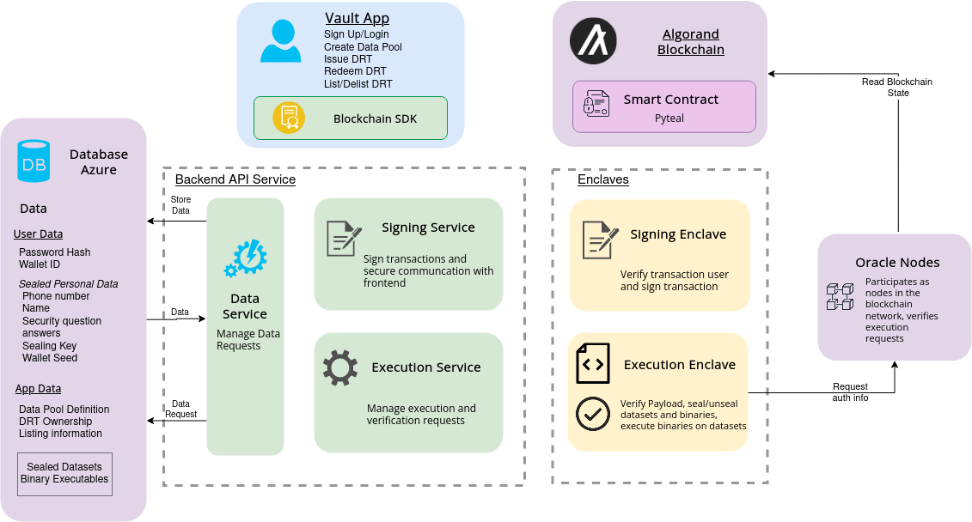

## Execution Enclave Systems/Flows/Operations

1. Untrusted Part
   1. Request oracle node for blockchain information
   2. Retrieve WASM binary
   3. Retrieve sealed data
2. Trusted Part
   1. Confirm blockchain info is genuine/correct
   2. Unseal sealed data
   3. Execute WASM binary on data

## Github experimental Repos

* <https://github.com/ntls-io/wasm-exec-sgx>
* <https://github.com/ntls-io/ntls-sgx-service>
  + Repo developed for “new auth system” for NW
  + The 3 ntc mvp functions developed in “util” branch by Tshepang weren’t developed for the system and are just some simple functions

## Implementation Plan and Timelines

1. Get wasm-exec-sgx production ready (3 weeks)
   1. Upgrade SGX SDK/Teaclave packages of the repo and make sure devs can build it locally (might not be needed) - 3 days
   2. Change function `exec_wasm_with_data` to take in json data - 3 days
      1. Create dataset ECAL and any necessary deserialization for a JSON dataset
   3. Retrieve execution result from trusted part - 1 week
      1. May have to do something with malorc or changing Enclave.config.xml Stack and Heap sizes
   4. Create 6 test json files with 6 different WASM binaries - 1 day
      1. Most of the WASM binaries should have been created by Bingle
   5. Deploy wasm-exec-sgx on Azure and setup `dev`, `staging`, `main` - 3 days
2. Integration with other parts of NTC (parallelizable, 4 weeks)
   1. Link up with Oracle Node (2 weeks)
      1. Untrusted part of execution enclave must be able to securely request and receive info from oracle node - 1 week
      2. Add function in trusted part to assess received info from oracle node, to run redemption or not - (1 week)
   2. Link up with sealing/unsealing dataset - 1 week
      1. Make sure can retrieve sealed data from Data service API - 2 days
      2. Make sure Execution Enclave can unseal data - 3 days
   3. Link up with Smart contracts (not sure)
      1. For append DRT, need row counter function
      2. …
   4. Link up with Vault (1 week)
      1. Send retrieved execution result to user on frontend securely